# CITY OF SAN DIMAS

City Council

**NOTICE OF INTENT TO ADOPT RECIRCULATED MITIGATED NEGATIVE**

**DECLARATION AND**

**NOTICE OF PUBLIC HEARING OF THE SAN DIMAS CITY COUNCIL**

**APPLICATION - PROJECT** Case No. MCTA 20-05

**DESCRIPTION**:

Consideration of a Municipal Code Text Amendment of Title 18-Zoning, Chapter 18.518 Specific Plan 11 of the San Dimas Municipal Code, to amend grading limits within Planning Area I and make various clean-up text amendments.

The proposed Municipal Code Text Amendment (MCTA) would allow for up to one thousand (1,000) cubic yards of grading, cut and fill, beyond that grading necessary for the primary residence, driveway and garage for properties located within SP-11 Planning Area 1 (36 residential lots, up to 36,000 CY grading). The proposed MCTA would also include development standards for the grading, landscaping and any retaining walls that the additional grading would require. Additional clean-up items are proposed by removing sections which dealt with the initial development of the area and codifying previous policies regarding Conditional Uses within the specific plan.

**PROJECT LOCATION:** Specific Plan 11, Area I

The Project Site is located within the southwestern portion of the City and is located within Area I of Specific Plan-11. Specific Plan-11, Area I is bordered by Puente Street to the north, Via Verde to the southeast, East Covina Hills Road to the southwest and the City of Covina to the west. The majority of the Specific Plan has been developed with single-family residences within hillside areas and is surrounded by existing hillside single-family residences. Local access to the Project Site is provided by Via Verde and regional access is provided by the San Bernardino Interstate-10 (I-10) Freeway, approximately 1-mile to the south.

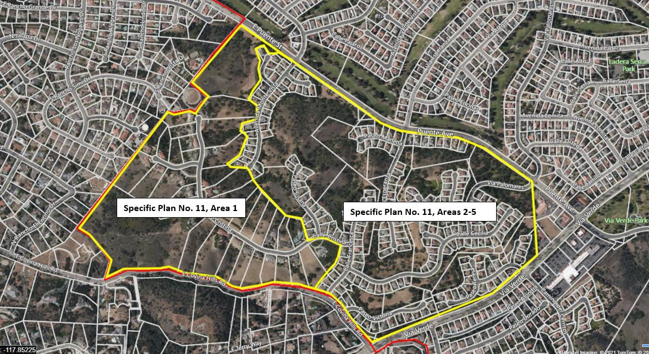

Entire Specific Plan No. 11 (project area) is highlighted in yellow.

**ENVIRONMENTAL: Additionally, the City of San Dimas hereby gives notice that pursuant to the authority and criteria contained in the California Environmental Quality Act (CEQA) and the CEQA Guidelines, Staff has analyzed the request for the following:**

After reviewing the Initial Study and any applicable mitigating measures for the project, Staff has determined that this project will not have a significant effect on the environment. Accordingly, a RECIRCULATED MITIGATED NEGATIVE DECLARATION has been prepared.

**Public comments on the Mitigated Negative Declaration were received by the City from JUNE 21, 2024, through 5:00 PM on July 21, 2024.** As stated above, a public hearing of the San Dimas City Council will be held to consider the proposed project and the proposed Mitigated Negative Declaration on Tuesday, December 10, 2024 at 7:00 PM in the San Dimas City Hall Council Chamber at 245 East Bonita Avenue, San Dimas CA 91773.

**PROJECT APPLICANT:** The City of San Dimas

**STAFF CONTACT:** Luis Torrico, Director of Community Development

[LTorrico@sandimasca.gov](mailto:LTorrico@sandimasca.gov), (909) 394-6250

**PUBLIC HEARING** Tuesday, December 10, 2024

**DATE AND TIME:** at 7:00 PM

**PUBLIC HEARING** City Hall Council Chamber

**LOCATION:** 245 E. Bonita Avenue

San Dimas, California 91773

Copies of all relevant material, including the project specifications and all documents referenced in the Recirculated Mitigated Negative Declaration, are available for public inspection at San Dimas City Hall, Planning Division, 245 East Bonita Avenue, San Dimas and the City of San Dimas website <https://sandimasca.gov/departments/community_development/planning_division/development_projects_environmental_info.php>. Electronic format of the document(s) can also be obtained by contacting Luis Torrico at 909.394.6250. City Hall is open Monday through Thursday, 7:30 a.m. to 5:30 p.m., and on Fridays from 7:30 a.m. to 4:30 p.m. The project site is not listed on any list of hazardous waste sites prepared pursuant to Government Code Section 65962.5. An electronic version of the project staff report will be made available after 4:30 p.m. on Friday, December 6, 2024 on the City’s website at: [www.sandimasca.gov/agendas-minutes](http://www.sandimasca.gov/agendas-minutes)

The City is requesting your participation in this public hearing process. If you are unable or do not desire to attend, you also have the opportunity to submit written comments in favor of or in opposition to this project. Correspondence should be addressed to the City of San Dimas, Community Development Department, 245 East Bonita Avenue, San Dimas, CA 91773. All comments must be received by no later than 5:00 p.m. on December 9, 2024, to ensure that the Planning Staff has time to print the emails and type verbal comments prior to the beginning of the meeting.

If you challenge the action taken on this project in court, you may be limited to raising only those issues you or someone else raised at the public hearing described in this notice, or in written correspondence delivered to the Planning Division Staff at, or prior to, this public hearing.